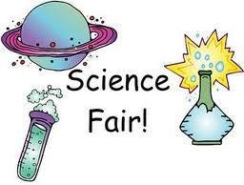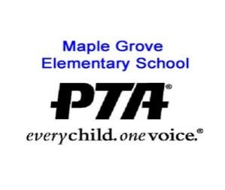

Dear students and parents:

Welcome to Maple Grove’s Science Fair! Please read this entire Information Guide. It will help you select and perform your project, prepare your Science Fair Notebook, create a display, if desired, and get your questions answered. Our Science Fair has five parts:

- Ask a question! Then design and perform an experiment or complete a demonstration project to answer the question.
- Write up the results in the Science Fair Notebook and if desired, prepare a display showing your process and its results.
- Set up the display at school.
- Discuss the project with a visiting scientist and explain it to other Maple Grove students.
- Attend the Science Fair celebration.

Each participant will receive a certificate signed by a visiting scientist, a Science Fair name badge and ribbon, and recognition during the Science Fair celebration.

The Science Fair is for all students at Maple Grove. Give it a try, we’ve got lots of resources to help you do your Science Fair project and have fun!

What to Find in This Guide:
- What is an Experiment vs. Demonstration? Pages 2-4
- Planning and Executing Your Project Pages 5-6
- Project Display Design and Setup Page 7
- Project Review and Recognition Page 8
- General Rules for the Science Fair Page 9
- Sources of Information Page 10
- Contact Information Page 11
1

Maple Grove’s Science Fair

All of science starts with a question! The Maple Grove Science Fair provides students the opportunity to explore their science questions and learn about science through either:
- Performing an experiment, or
- Demonstrating and describing a scientific principal or fact

I. Perform an Experiment using the Scientific Method
These projects allow students to pose a problem, design an experiment to investigate that problem, and record and report their results. The scientific method should be used when performing any experiment. The scientific method is a series of steps that will help a student systematically investigate the relationships he or she has observed. This process is summarized below and explained in more detail under item IV.

- Ask a question or present a problem that can be stated in terms of a hypothesis (an initial guess) that can be tested.

- Design and perform an experiment to check the initial guess or hypothesis. An experiment is the tests done to check the hypothesis (initial guess). To design the experiment, the student must make a guess about the things that affect the system they want to investigate. These are called variables, because varying one of these things may change the results of the experiment. Be sure to record the results of your experiment in your Science Fair Notebook!

- Perform your experiment. Do your experiment, observe everything that happens and record it in your Science Fair Notebook.

- Summarize and draw conclusions. Summarize the results of your experiment and draw conclusions about the hypothesis and variables used in the experiment.

- Something went wrong? It’s OK if your experiment didn’t turn out as you expected! Try to understand what happened to cause the results you observed. What did you learn from your experiment? Turn it in any way! You learned something!

II. Research a Demonstration Project
For a demonstration project, students demonstrate and/or describe a particular science principle or fact. The demonstration may showcase how something works, a science fact or phenomenon, or how something is created. A demonstration should show how the answer to a specific question was researched and discovered.

- Ask a question! How does this work? Why does this happen? Kids are full of questions, and a science fair is an excellent time to explore these questions further and find the science behind the answers.

- Research your question. This can be done through research at the library or on the internet, or visiting a museum or lab, or interviewing an expert. Be sure to record the resources you used to find the answer to your question.

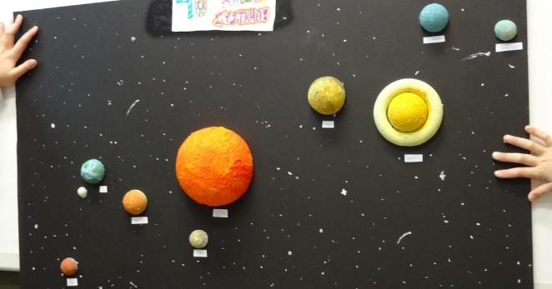
- Create a model or display. With a demonstration project it is important to show people what your research found in a clear and easy to understand way. This should include an explanation of the scientific facts and principals that you found and show examples of these principals and facts.

- Summarize and draw conclusions. Summarize the results of your research and discuss anything that you did not expect to find.

III. Is it an experiment or a demonstration?
When you think of science fairs, you will usually conjure images of erupting model volcanos or a model of our solar system. Those are typically demonstration projects, explaining a scientific fact or principal. This is generally where scientific exploration starts, with a “how does that work?” question.

The next step of scientific exploration is typically experimentation. You have studied a subject, modeled it and think that you understand it, but how can you be sure your theories are correct? And what if some new variable is introduced? If you come up with a topic and you want to do an experiment rather than a demonstration project, try to turn the topic into a question that can be answered by an experiment. We have provided some examples below.

Examples:
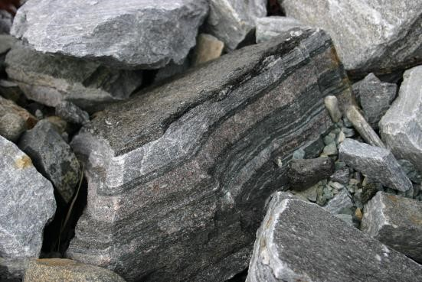
Question: What types of rocks are found in Colorado?
Demonstration: Collect and categorize different rocks that you find around Colorado and research what type of rocks they are and how they are formed differently.
Experiment: Are some rocks found in Colorado harder than others? Is there a way to predict which ones?

Question: How do heavy boats still float?
Demonstration: Construct a model of a boat and explain how it floats.
Experiment: Does the shape of the boat affect whether or not it floats? Does the material used to make the boat make a difference?

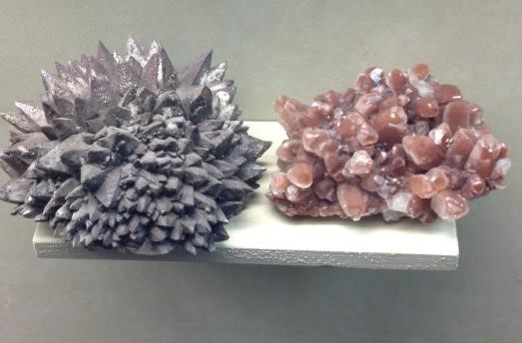
Question: Why do some crystals look different than others?
Demonstration: Grow crystals in a jar, or look at crystals under a microscope, and explain how and why they grow in specific shapes and patterns. Experiment: Does crystal size depend on the temperature of the solution used to grow the crystals?

IV. Planning and Executing Your Project
A. Ask a question!
The following guidelines apply to all students at Maple Grove; please use them to develop an age-appropriate Science Fair project.

- Ask a question that you want to explore the answer to. Or present a problem that can be stated in terms of a hypothesis (an initial guess) that can be tested.
- Sometimes you notice something and wonder why it happens, or you see something and wonder what causes it. Write down what you noticed and your question.
- Next, find out more about what you observed by reading books, magazines, and internet articles, or talking with family, teachers, and librarians. Or visit a museum and talk to the experts there. Check the end of this guide for Sources of Information. Keep track of where you find your information.
- For demonstrations, takes notes explaining how you will display the information you found. See if there are pictures in the research that you can use for your display or if there are objects to be constructed to show your question and answer.
- For experiments, develop a hypothesis (an initial guess) as to what the answer to your question might be. The hypothesis must be stated in a way that can be tested by an experiment.
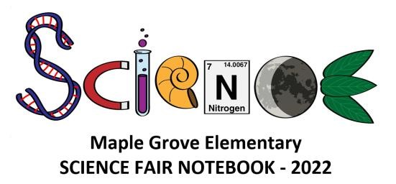
◦ Example: “Does fresh water freeze more quickly than salt water?” Your hypothesis could be, “I think salt water will freeze more quickly than fresh water.” You could then test your hypothesis by timing how long it takes for fresh water and salt water to freeze.
◦ Write your question and your hypothesis in your Science Fair Notebook. Think about the purpose of your experiment and write it in your Science Fair Notebook.

B. How to Design an Experiment (if applicable)
- Make a guess about the things that affect the system you want to investigate. These are called variables, because varying one of these things may change the results of your experiment.
- Make a step-by-step list of the things you want to change to check your hypothesis.
- Write a procedure (directions) explaining how you will conduct your experiment and how you will measure your results. A good experiment produces results that can be measured and repeated by someone else. Write your procedures and the variables you plan to change in your Science Fair Notebook.
◦ Example: For the experiment described above, you could vary the amount of salt dissolved in the water, or salinity of water, that you freeze to see if the amount of salt in the water will affect the speed of freezing.

C. Perform your experiment (if applicable)
- Make a list of materials you will need to perform the experiment and gather them. Write them in your Science Fair Notebook.
- Do your experiment. Observe everything that happens and record it in your Science Fair Notebook. Be very careful when taking measurements or making observations; record the measurement or observation and the time of the measurement in your notebook.
- Don’t forget to write down anything unusual that happens or any problems you have. These may not seem important at the time but may help you understand the results of your experiment, or lead you to the next question that you want to explore!

D. Something in your experiment went wrong? (if applicable)
• It’s OK if your experiment didn’t turn out as you expected. Try to understand what happened to cause the results you observed. Write the explanation in your Science Fair Notebook. What did you learn from your experiment? You may only have learned that your hypothesis was wrong. That’s OK; turn it in anyway! You learned something. Maybe a visiting scientist can help you figure out what went wrong with your experiment or why your hypothesis was incorrect. Many important things have been learned by experiments that “didn’t work.”
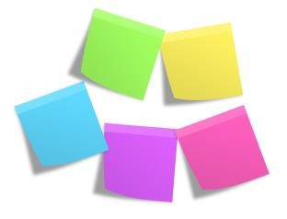
◦ Example: The scientist who invented Post-it Notes did it by accident. He was trying to invent a new adhesive that would permanently stick notes to a surface. His adhesive didn’t do what he had hoped, but it created a whole new way of posting notes!

E. Summarize and draw conclusions
- Summarize what happened during your experiment, or in researching your demonstration project, and write it in your Science Fair Notebook. For experiments, try to determine all of the possible causes for the results.
- Explain what you learned from your experiment or demonstration. Did it answer your original question? Did it lead to any new questions? Was your hypothesis correct? Why or why not?

V. Project Display Design and Setup
The most important thing in the Science Fair is to ask a scientific question and find the answer, either through an experiment or research. You must write up your question and answer in the Science Fair Notebook. A display showing your project is not necessary for an experiment; however, it is necessary for a demonstration project. It also makes an experiment much more interesting for everyone to see what you did. Your display should show:
- Your question
- Your hypothesis
- Your experiment or research
- Your results

Be creative! Use large type, color, eye-catching drawings and photographs, or 3-dimensional graphs. Think about what will draw the observer to your display. It’s OK to use a computer to make your display as long as you do the work yourself (parents may assist younger students).

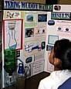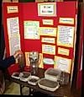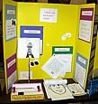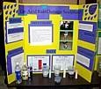

You can purchase your display board at an Office products store, Walmart, or Target. Display boards are 3-sided (30" by 30").

Display Guidelines
- Each person must have a Science Fair Notebook.
- You must provide all equipment for your display (including an extension cord).
- Contact us if you have special requirements for your display (floor space, wall, specific height or electrical outlet).
- A team may submit either a combined display or separate displays.

Display Setup
- Display set-up is after school the day before Science Fair.

Display Protection
- The school assumes no responsibility for loss or damage to equipment and materials.
- Valuable instruments, manuscripts, or object should be left at home.
Tip: Although a scientist may wish to present a “hands-on” display, please understand that it may not remain intact until the evening celebration.

VI. Project Review and Recognition

You’ve finished your project, Science Fair Notebook, and set up your display. Now what?

On Science Fair Day, a visiting professional scientist will review your project. They will ask you to explain what you did and what you learned. If you have questions about your experiment or its results, ask the visiting scientist!

Now that you have completed your Science Fair project, you have joined the ranks of “Maple Grove Scientists.” In recognition of your hard work, you will be awarded a certificate. Because this is not a competition, there will be no “winner” of the Science Fair. There are awards given for number of years of participation and some fun awards like “Grossest experiment”.

You will receive a certificate if you have done the following:
- Demonstrated knowledge of your experiment and results
- Included the Science Fair Notebook with your display
- Demonstrate that you conducted most of the work yourself

On Science Fair night, you, your family, and friends are invited to the Science Fair celebration. Everyone can view all of the Science Fair displays and attend the reception where fun awards are given out!

After the Science Fair celebration, you must take down your display and take it home. If you cannot attend the Science Fair celebration, please make arrangements to have your display taken down by a friend after the celebration.

General Rules for Science Fair
- You or your team must design and perform the experiment or project. Outside help is allowed as appropriate for the age and safety of the students.
- You cannot repeat one of your previous Science Fair projects, unless you are looking at a new variable, expect different results, or have a different explanation.
- Live subjects (animals, insects, or friends!) must not be harmed during your experiment.
- Prohibited Items include:
  - Open or concealed flames
  - Combustible or flammable materials
  - Dangerous chemicals or concentrated caustics or acids
  - Live disease-causing microorganisms
  - Live or dead microbial cultures or fungi
  - Unknown specimens that could be a public health hazard
- High voltage wiring, switches, and metal parts must be located out of reach of observers and designed with an adequate overload safety factor. All wiring must be properly insulated and installed.
- Teams of siblings or friends may work on a project together. Guidelines for team projects are given below.
- Siblings may work together on a project. The work can be divided based on each student’s ability level and particular talents.
- Friends may work together on a project, as long as the work is divided evenly among all team members.
The Science Fair Committee has found that team projects can lead to strained friendships if one person does not do their share of the work or decides to pull out at the last minute.
- All teams must follow these rules:
- Each team member must know and understand the entire project.
- Each team must complete a Science Fair Notebook.
- The team may complete one display or separate displays for each team member.
- Each team member will have their project reviewed individually and receive a separate certificate.

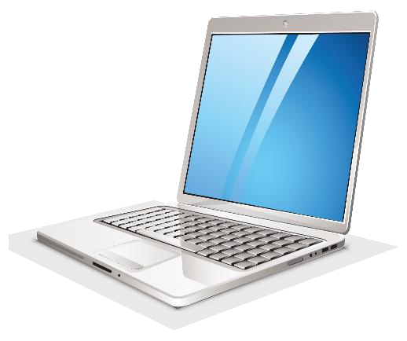

Sources of Information

Below are some sources of information on science fairs, science fair projects, and basic scientific stuff! If you’re having trouble coming up with a project question or an experiment, maybe these will help.
- Look for additional information labeled “Science Fair Project Question Ideas”. The list includes past Science Fair Questions that are categorized by topic area.
- Check out the Internet: Most search engines (e.g., Google) will reveal numerous websites by searching under “science fair”, “science experiments". Additionally, here are some good sites:
http://www.stevespanglerscience.com/ http://www.education.com/science-fair/ http://www.exploratorium.edu/ - Search for Science Experiments on the site.
http://www.dietspotlight.com/nutrition-diet-food-science-experiments/ https://www.eduplace.com/science/profdev/science_fair/index.html
- Talk to your parents, teachers, or other students. They may be able to help you come up with the perfect project.
- Go to museums and exhibits in the Denver area. Not only are they fun to see, they have great resources in their libraries and gift shops!
- Denver Museum of Nature and Science
- Denver Zoo
- Children’s Museum
- Butterfly Pavilion

Contact us if…
- You have a question about your project or you can’t turn your idea into a project question.
- Your experiment failed! We can help!
- You can't set up at the scheduled times.
- You need to drop out of the Science Fair (please don't, it's fun!)
- You can't attend the Science Fair celebration.

Brian Hansen, Science Fair Chairperson:

hanseninc@gmail.com or 720-470-4304

